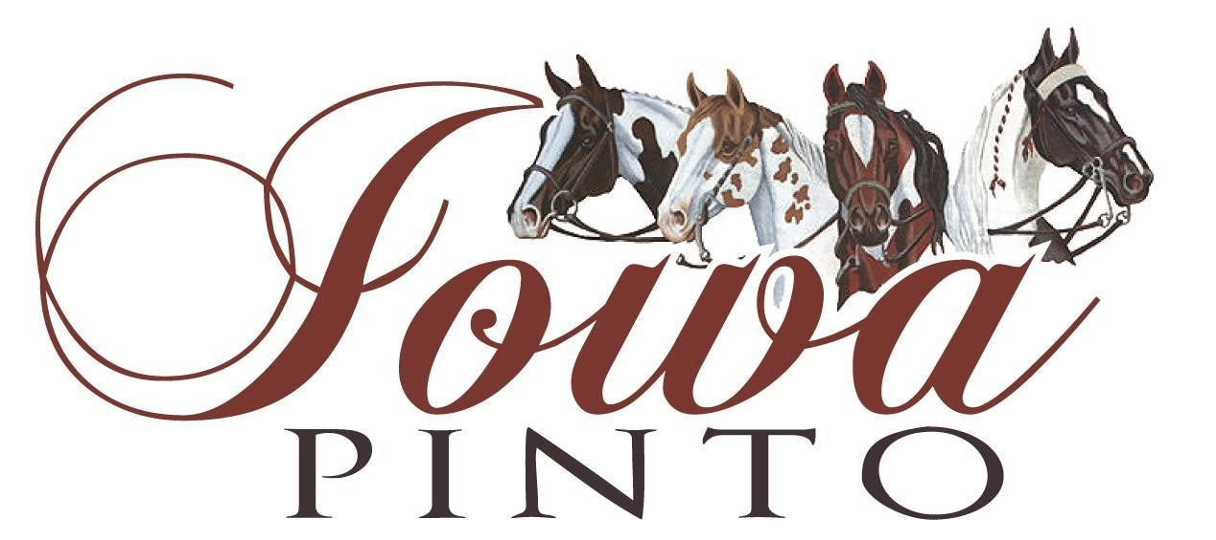

Yearling Triad Year End Award Nomination Form

The goal of the awards program is to recognize the accomplishments of the yearlings throughout the show season.

Qualifications:

- Must be current paid members of the Iowa Pinto Horse Association.
- Points from ONLY ABO classes listed below sponsored by Iowa Pinto will count towards the award.
  - Classes : ABO Halter Yearlings, ABO Yearling In Hand Trail, ABO Yearling Longe Line
- Award will be given to horse/handler combo that accumulates the most total points in a given year at Iowa Pinto shows.
- A nomination fee of $10.00 will be required with the appropriate paperwork. Points do not begin to count until the nomination fee is paid.

Name of Exhibitor:
Registered Name of Horse:
Date Nominated:

